CHAPTER 1: WHAT IS THE NCBA

CHAPTER 1: WHAT IS THE NCBA 1
MISSION STATEMENT 2
HISTORY OF THE NCBA 3
2014 NCBA DIVISION I TEAMS BY CONFERENCE 4
2014 NCBA DIVISION II TEAMS BY DISTRICT 5
OVERVIEW OF THE LEAGUE 6
Conference Coordinator 6
Regional Director 6
District Coordinator 6
Scheduling 6
Conference/District Play 7
Non-Conference Games 7
Eligibility 7
Roster 7
Cost 8
Spring Training 8
Regional Playoffs (Division I) 8
District Playoffs (Division II) 8
World Series 2014 9
Annual League Meeting 9
Rules Committee Meeting 9
NCBA WEBSITES 10
Using the Website 10
Contributing to the Website 12
BENEFITS OF BEING IN THE NCBA 14
On the Field 14
Off the Field 14
FRONT OFFICE CONTACT INFORMATION 16

MISSION STATEMENT

The National Club Baseball Association, L.L.C. (NCBA) is the fastest-growing inter-collegiate baseball league in the United States.

We are driven to provide collegiate student-athletes with the opportunity to play competitive, organized college baseball, and to continually enhance this experience for all participants.

We strive to accomplish this by building lasting relationships based upon trust, commitment, dedication, understanding, and strong lines of communication.

HISTORY OF THE NCBA

The National Club Baseball Association (NCBA) is the first ever, national governing body for collegiate club baseball. Founded in 2000 by former Penn State Baseball Club player and president, Sandy Sanderson, the initial season had 34 club baseball teams from across the country competing in the league. In the years since its commencement, the league has grown tremendously with 250 member baseball teams during the 2014 season. The NCBA annually provides more than 4,700 college students with the chance to continue their competitive baseball careers and contend for a true national championship.

There are a number of former NCBA baseball players who began their careers on the club team at their school before moving on to play for their NCAA Division I programs, while several others have gone on to play professional baseball in the independent leagues. Major League Baseball made full acknowledgement of the league’s talent when the Florida Marlins drafted Colorado State pitcher Nathan Nowicki in the 19th round of the 2003 Amateur Player Draft. Nate holds the designation of being the first player drafted out of the NCBA but certainly not the last. Following Nate’s 2003 selection, the Anaheim Angels selected RHP Chris Waters in the 16th round of the 2004 Amateur Player Draft. Chris had spent 3 seasons on the Clemson Club team before transferring to the University of North Florida (DII) to finish his senior campaign. Then in 2005, Steve Schmoll formerly of the University of Maryland Club team had the distinguished honor of making his Major League debut for the Los Angeles Dodgers. Since then several other players have been drafted or have been picked up via Free Agency by Professional Ball Clubs.

Upon seeing the success of the baseball league over the years, many collegiate club softball teams began to take notice and wondered why there was no league for them. Thus in 2006, the NCBA started the National Club Softball Association (NCSA). With an initial membership total of 36 teams for the inaugural season and substantial growth since then, the NCSA appears to be off and running at a similar pace as the NCBA with nearly 100 member teams in 2014.

In 2007, the NCBA began to realize that an obvious disparity in talent level was developing with in the league. Smaller schools and first year programs were struggling to be competitive with some of the club baseball programs from larger schools or those that had been in operation for many years. In an effort to both even the playing field and maximize the club baseball experience for all teams in the league, the NCBA split in to two divisions (DI and DII). Division I teams compete for the chance to play in Regional Tournaments at the end of the season with the Regional winners move on to compete in the DI World Series. Division II teams compete for the chance to play in District Playoffs and thus the chance to play in the DII World Series at the end of the season.

2014 NCBA DIVISION I TEAMS BY CONFERENCE

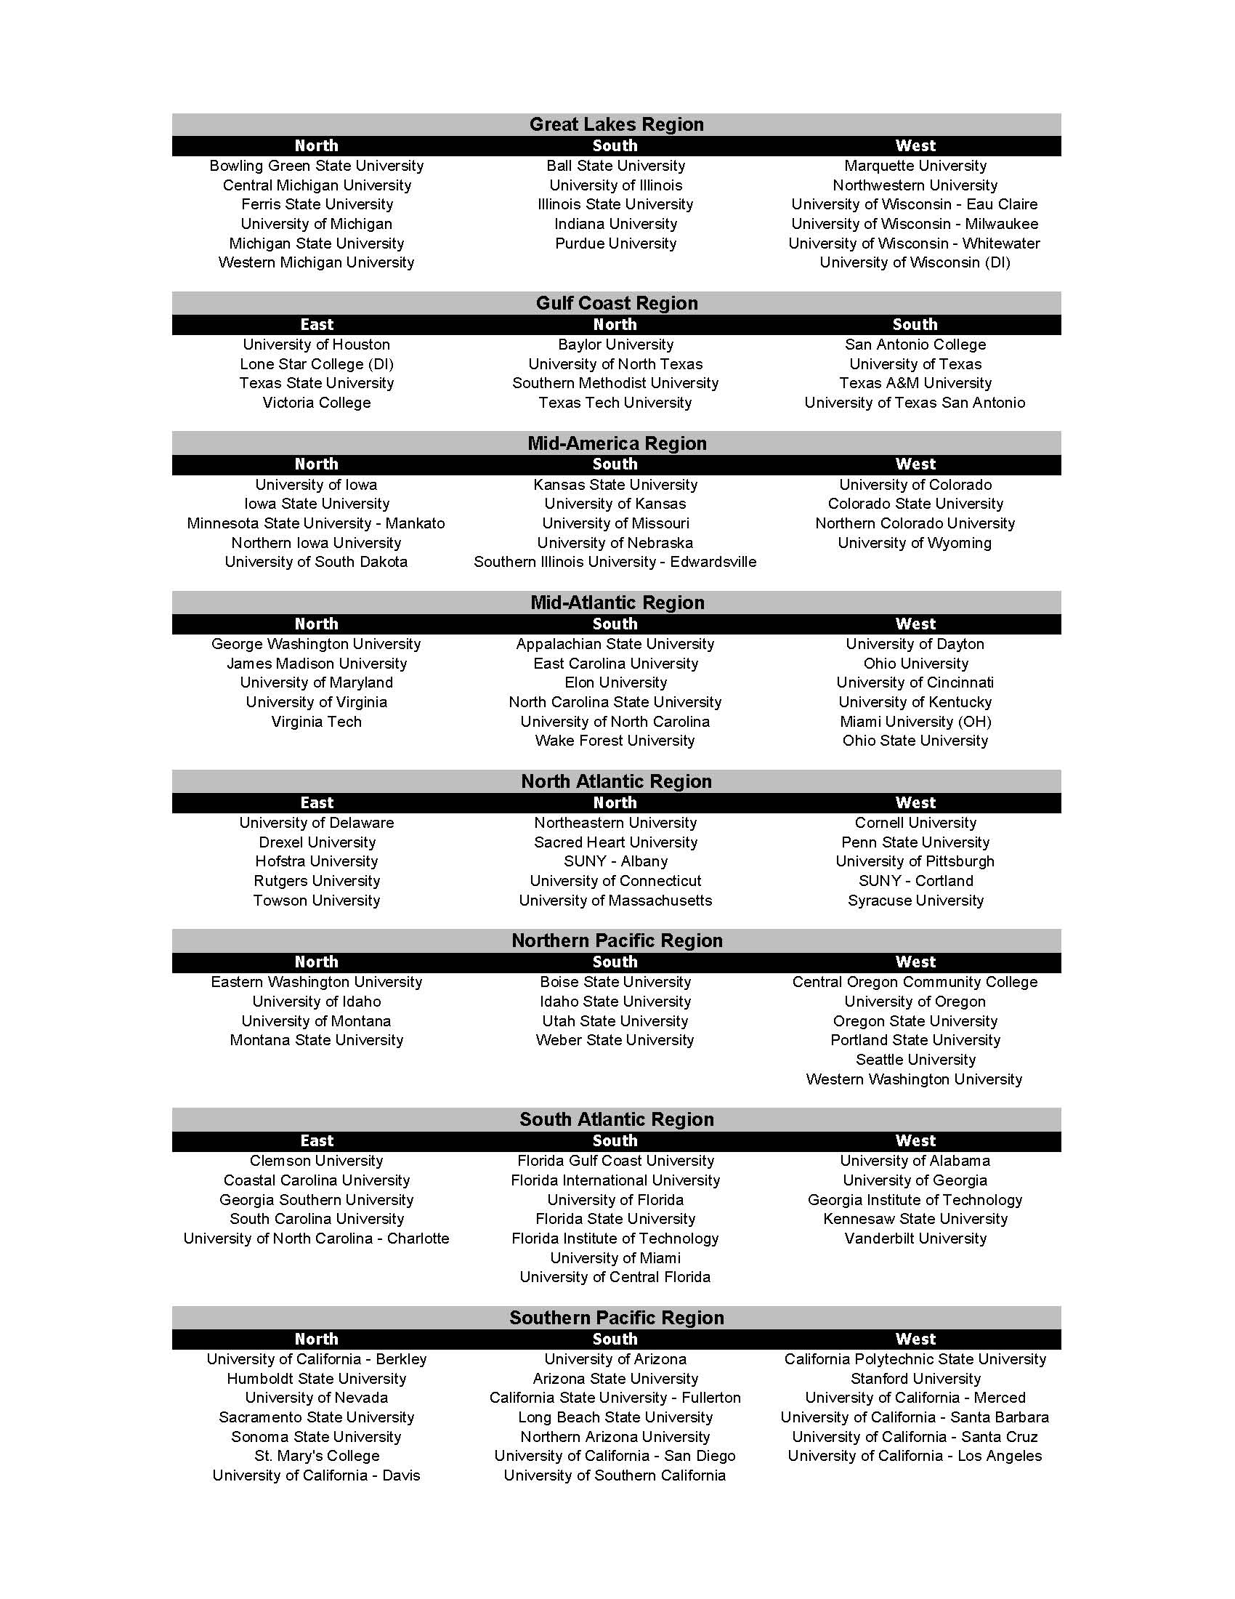

2014 NCBA DIVISION II TEAMS BY DISTRICT

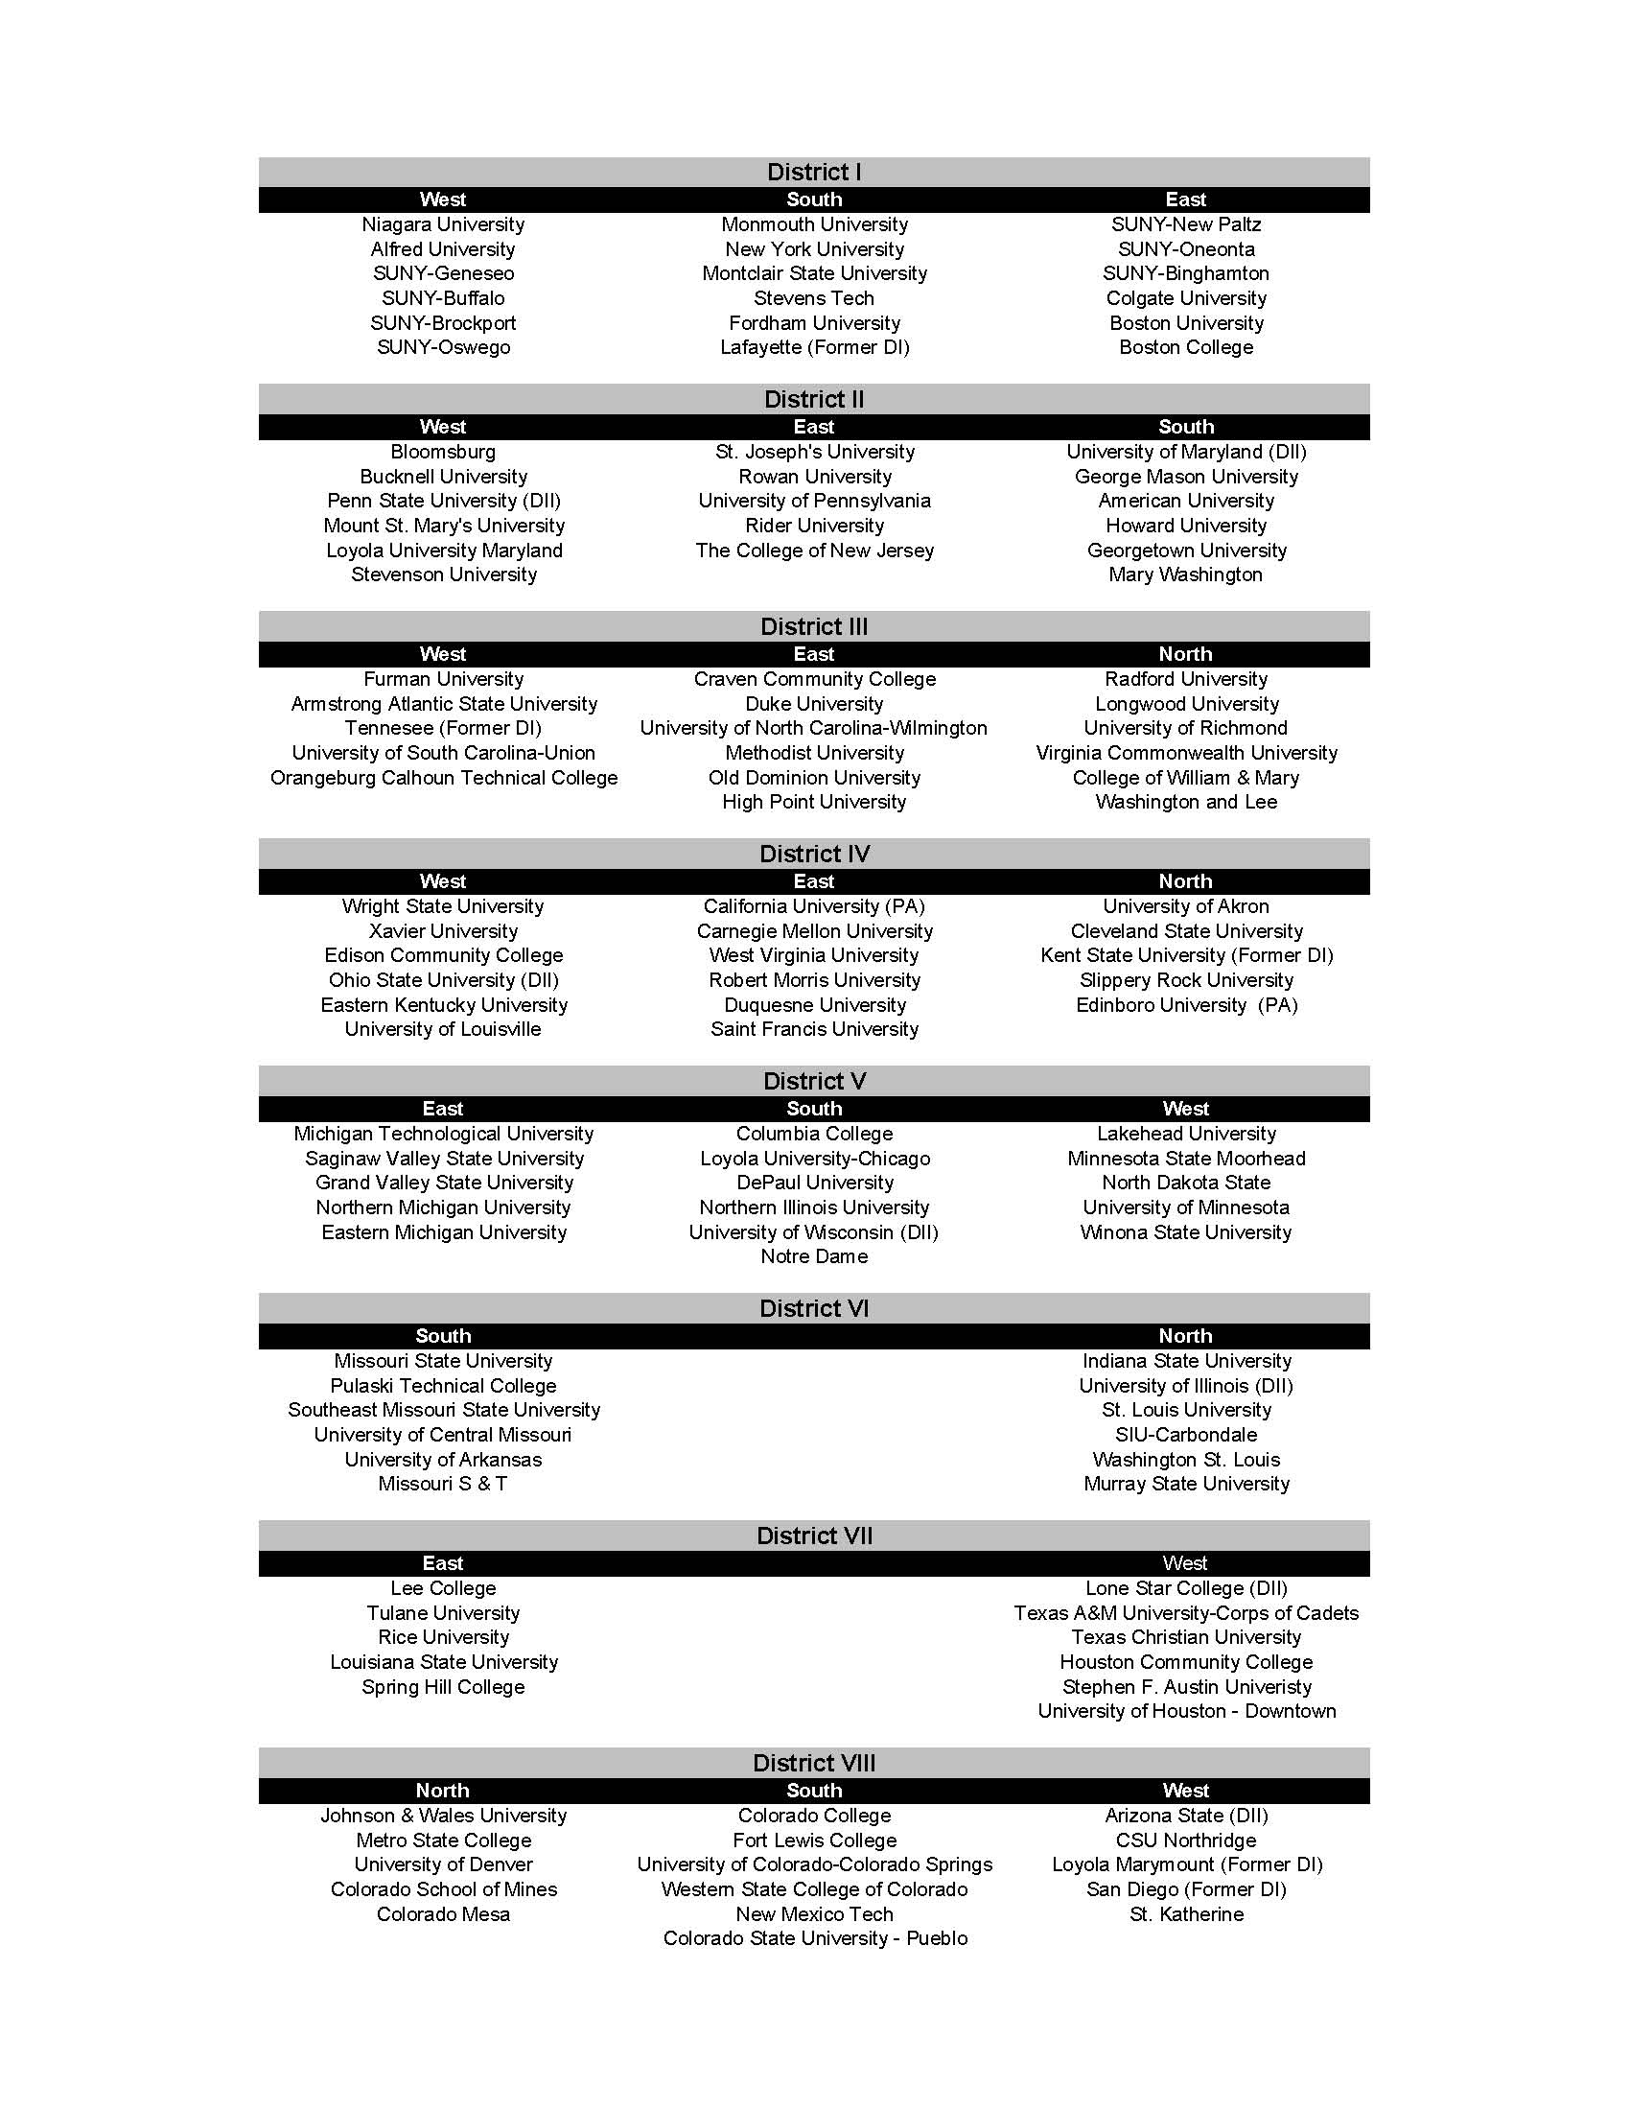

OVERVIEW OF THE LEAGUE

Conference Coordinator
Each Division I conference in the NCBA is run by a Conference Coordinator. This person is a member of the NCBA staff and is responsible for putting out the conference schedule, uploading the rosters of each team in the conference onto the website, uploading game results onto the website, and selecting and posting (on the website) conference player and pitcher of the week. Additionally, the Conference Coordinator is the person that the teams in the conference submit their paperwork to and who the teams turn to with questions or for advice throughout the year.

Regional Director
Division I Regions in the NCBA are made up of (2) or more conferences. Each Region is run by a Regional Director who is a member of the NCBA staff responsible for overseeing all conferences in that region. The Regional Director is also responsible for hosting the Postseason Regional Tournament. In most cases, the Regional Director also serves as the Conference Coordinator, but when this is not the case the Conference Coordinators reports directly to the Regional Director.

District Coordinator
Each Division II District in the NCBA is run by a District Coordinator. This person is a member of the NCBA staff and is responsible for putting out the district schedule, uploading the rosters of each team in the district onto the website, uploading game results onto the website, and selecting and posting (on the website) district player and pitcher of the week. Additionally, the District Coordinator is the person that the teams in the district submit their paperwork to and who the teams turn to with questions or for advice throughout the year.

Scheduling
Each team will submit a Scheduling Request Form to their Conference Coordinator/Regional Director or District Coordinator prior to the season. This form covers the entire season of play and allows teams to indicate when they are available for home games, when they are available to travel, and when they are unavailable to play. The Conference Coordinator/Regional Director or District Coordinator then uses these forms to create the conference schedule. The schedule (which is posted on the website) indicates which teams are playing during which weeks and who the home team is. It is then up to the teams to contact each other and set up the specific day(s) and times they will be playing their conference games. There are two types of Schedule Request forms. One is for teams that play NCBA Sanctioned games in both the Fall and the Spring and the other Schedule Request Form is for teams who only play in the Spring.

Conference/District Play
Teams are placed in conferences based on geographic location. The NCBA will put out conference schedules at the beginning of the fall semester for the entire season, which covers both the fall and spring semesters for teams who play conference games during that time. Teams who only play conference games in the Spring will also have their schedule sometime at the beginning of the Fall Semester. In conferences or districts with 4 teams, each team will play each other team in one home 3-game series and one away 3-game series. In NCBA Division I, conferences with 3 teams or less, each team will play each other in one 4-game series and one 3-game series, one home and one away. The schedule may dictate that you play both series in the fall, both in the spring, or one in the fall and one in the spring. In conferences or districts with 5 or more teams, each team will play each other team in one 3-game series in either the fall or the spring. In this case, teams will alternate home and away series each year.

Non-Conference Games
Teams are encouraged to schedule additional non-conference games for weeks they are not scheduled to play conference or district games. Such games can be against NCBA teams, non-NCBA club teams, or Collegiate Varsity teams. Teams can play in and host tournaments that we can announce on the NCBA website. Teams should inform their conference or district coordinator as they add non-conference games to their schedules so these games can be added to the schedule on the website. Stats from non-conference games do count for players and game results count towards the team’s overall record, not their conference record.

Eligibility
In order to be considered eligible, a player must meet the following academic requirements:
- Must hold full-time student status at the team’s college/university
*an exception is made if it is the final semester for a student and he requires less than a full-time load to graduate
- Must have a cumulative GPA of 2.0 or higher
- Must not be on academic warning or probation
- Must not have any previous professional experience in the sport of baseball
- Must be enrolled with Full-Time Status before their 25th Birthday.
- Each player must complete his five years of participation in intercollegiate baseball within six calendar year of first enrolling full time in college

Roster
Each team’s roster appears on the NCBA website. In order to be added to the roster, each player must complete the NCBA Online Registration Process. Each player’s name must also appear on an Academic Eligibility Letter stating that he meets all of the academic eligibility requirements. This letter must be signed by the Director of Rec/Club Sports, the University Registrar, or an advisor. A player is not considered eligible until the player is appears on the online roster.

Cost
Registration Fee: Upon joining the NCBA and submitting a signed League Participation Agreement, a team will pay a one-time registration fee of $600.
Dues: Division I Yearly dues of $1700 + $300 Performance Bond and Division II Dues of $1500 are due by February 28th of that season. Teams will receive a $100 discount if dues are received in full by December 31st of that season.

Spring Training
Collegiate club baseball teams have the opportunity to attend the NCBA Spring Training Showcase, which is held in Plant City, Florida and runs from the last week in February through the first week of April. Teams sign up for the week of their Spring Break and submit a scheduling request form indicating how many games and what days they want to play. The NCBA then sets up games between teams that will be attending Spring Training during the same week. NCBA member teams receive a discount on the registration fee to participate in the Spring Training Showcase. More information can be found at http://springtraining.clubbaseball.org or by contacting our Director of Spring Training Operations, Savannah Ahrens at Savnnah.Ahrens@CollClubSports.com or by phone at 412-321-8440 x103.

Regional Playoffs (Division I)
Every year each Division I Region of the NCBA has a post season tournament often referred to as “Regional’s”. The Regional Director is responsible for organizing and overseeing this tournament. The number of conferences and teams in a particular Region will determine who qualifies for this tournament. For regions with two conferences and 12 teams or more, the top two in each conference will advance to the Regional Tournament. For Regions with two conferences and less than twelve teams, the winners of each conference will advance to the Regional Tournament. For regions with three conferences, each conference winner advances to the Regional Tournament as well as an “at large” team which will be determined by the NCBA. This is NOT a “wild card”. For regions with four conferences, each conference winner will advance to the Regional Tournament. The winner from each Regional Tournament will advance to the NCBA World Series.

District Playoffs (Division II)
Every year each District of the NCBA has a post season tournament. The District Coordinator is responsible for organizing and overseeing this tournament. The number of conferences and teams in a particular District will determine who qualifies. The number of teams participating in each District Playoff is exactly like the Regional Format described above. The winners of each District Playoff will advance to the NCBA DII World Series.

World Series 2014
Division I
The 2014 Division I World Series was hosted by the NCBA on May 23-29 at The University of Tampa in Tampa, FL. The winners from each regional tournament received an automatic bid to the NCBA Division I World Series. A total of eight teams competed in the double-elimination tournament, culminating in the crowning of the 2013 NCBA Division I National Champion, the Utah State University Aggies.

Division II
The 2014 Division II World Series was hosted by the NCBA May 16-20 at Brooks Stadium in Paducah, KY. The winners from each District Tournament received an automatic bid to the NCBA Division II World Series. A total of eight teams competed in the double-elimination tournament, culminating in the crowning of the 2014 NCBA DII National Champion, Texas A&M Corps of Cadets Aggies.

Annual League Meeting
With the great success of the 2013-14 NCBA Annual League Meeting being hosted online, the concept for the 14-15 Annual League Meeting will remain the same. Anyone can attend the meeting from the comfort of their own homes. All teams, players, past and present, along with any club baseball enthusiasts are invited to this meeting to interact with the NCBA staff and discuss both current and future (potential) issues. This meeting provides an opportunity for teams to learn more about all aspects of the NCBA as well as a chance to voice their opinions, ask questions, and provide feedback. The meeting consists of a brief overview of the year and the changes that have been implemented since the previous season. The meeting incorporates everything you will need to know about the NCBA, past, present and future. With the format of the meeting being online, the NCBA expects a fantastic turnout once again, which will in turn only make the NCBA better each and every single year. The 2014-15 Annual League Meeting will take place August 13th, 2014 at 7:00pm EST.

Rules Committee Meeting
A rules committee meeting is held every year and consists of the 8 Regional Directors, the Division I and Division II Rules Committee Teams Rep, and the President of the NCBA. The meeting involves the discussion of future rule changes. The participants present at this meeting will also vote on these rule changes. Teams are invited to share all thoughts, views, and opinions with their Regional Director or the Division I Rules Committee Teams Rep, Ed Gravell (gravellinsights@gmail.com), or the Division II Rules Committee Teams Rep, Rich Fiore (Rich.Fiore@hubaseballclub.com) as they will represent all Division I and Division II teams at this meeting respectively.

NCBA WEBSITES

The official website of NCBA Division I is www.clubbaseball.org and NCBA Division II is www.clubbaseball.org/Div2/ . These websites are a great resource for the teams as well as their fans, family, school, and potential sponsors. Upon joining the league, a team is added to the website as an official member of the NCBA. They are then given access to not only use the site but to also contribute to its content.

Using the Website
Home Page
The home page gives you links to all the other parts of the website. It also posts current NCBA headlines as well as a scrolling “Stat Tracker” that shows the league leaders in both offensive and pitching categories. You can also find the National Player and Pitcher of the Week featured on the home page as well as links to more information about our sponsors.

Shop Page
The “Shop” link is located in the menu bar towards the top of the page. This link takes you to the apparel marketplace for CollClubSports including the NCBA, NCSA and the rest of the CollClubSports Leagues. Browse everything that is offered including hats, visors, polo’s, and more.

Teams
Clicking the “TEAMS” link in the menu bar allows you to view all the teams in the league along with each team’s official website, roster, and overall stats for each individual player on that team.

Conference Pages
Teams can see all the conferences or districts by clicking on the “CONFERENCES” link in the menu bar towards the top of the page. Teams can then navigate to the individual conference or district pages which display that conference’s or district’s schedule, team standings, headlines, and player and pitcher of the week.

Stats Page
The website is a great way for teams to track their competition. Clicking on the “STATS” link allows you to see the top players in the league in individual offensive and pitching categories. It allows teams to track the progress of individual players throughout the league presently and in past seasons.

Schedules Page
Clicking on the “SCHEDULES” link in the menu bar allows you to see the weekly schedules for the current and previous NCBA season’s. Users can use the dropdown boxes to select any combination of which specific week, conference and/or team they would like to see. Past season schedules are also available to view using the “Season” drop down box.

Standings Page
Clicking on the “STANDINGS” link in the menu bar displays the current standings for each conference or district in the league. This is useful in not only knowing where you stand in your own conference or district, but also seeing where other teams stand within their respective conferences or districts. Again, previous year’s standings can be viewed by using the dropdown box next to “Season.”

World Series
Clicking the “WORLD SERIES” link in the menu bar takes you to information about the World Series that will take place during the current season. Following this link will give teams information about dates, locations, travel deals, hotel accommodations, and people they need to contact regarding the World Series.

Spring Training
Information about the NCBA Spring Training Showcase can be found by following this link: http://springtraining.clubbaseball.org/. This link leads to the Spring Training Showcase homepage which holds links to the pages for both the baseball and softball events. The Spring Training Showcase page contains information about dates, locations, travel deals, hotel accommodations, and people to contact regarding Spring Training.

Info Page
The “Info” tab is located at the top right portion of the page. This is a very valuable page as it contains press releases regarding the league, sponsors, and partnerships. This page also contains many of the documents teams will use throughout the year.

Contact Page
The “Contact” tab is located at the top right portion of the page. This page contains contact information the NCBA staff, and a breakdown of all the teams in the NCBA along with their specific websites.

Advertising Page
The “Advertising” tab is located at the top right portion of the page. This page contains information on how you can advertise with the league and contact information on who to contact.

Login Page
The “Login” tab is located at the top right portion of the page. This page has two Login Options. The first is the “Player Registration Login” which allows potential NCBA players to register online in order to have the opportunity to participate in the NCBA. The other option is the “Site Manager Login” which allows Administration, Conference Coordinators or Team Managers to login using their Username and Password to gain access to the NCBA site Manager.

Contributing to the Website
Username and Password
Team Managers are given a unique username and password that allows them to access their team’s information. In order for teams to obtain their specific username and password, they must first email either the VP of Baseball Operations, Christian Smith at Christian.Smith@CollClubSports.com or the Director of DII Baseball Operations, Eric Curitore at Eric.Curitore@CollClubSports.com. Division I teams email, Christian and Division II teams email Eric. Teams will then be given their username and password to login to the website by clicking the “Login” tab in the upper right portion of the webpage and selecting “Site Manager Login.”

Team Information
Teams can update the information that is displayed on the “TEAMS” and “CONTACTS” pages which includes the team’s website, and the team’s logo.

Player Bios and Pics
Each individual player that registers online, has the opportunity to add their bio and picture to the NCBA site. Players can click on the “Login” tab in the upper right portion of the NCBA website and then select “Player Registration Login.” Players will be asked several questions, and will have the opportunity to upload a bio and picture.

Player Statistics
Team Managers using their username and password can upload both offensive and pitching statistics for each player on their roster. These stats can be viewed by clicking on the individual player’s name on their team’s roster. Uploading these stats also gives players the chance to be recognized as a league leader in different categories, which can be seen on the stats page as well as the “Stat Tracker” on the homepage.

Pitcher/Player of the Week
Each team must submit a “Weekly Submission Form” to their conference or district coordinator by midnight on Monday of each week. This form contains the results of their games from the previous week as well as nominations of members of their team for Pitcher and Player of the Week honors. Each conference or district coordinator selects a Pitcher and Player of the Week for his/her conference and posts them on the conference or district page. From the conference or district pitchers/players of the week, a National Pitcher and Player of the Week are chosen and posted on the homepage of the websites.

Headlines
Teams are encouraged to contribute to the website by submitting published articles about their team to their conference or district coordinator. Such articles are featured in the “NCBA Headlines” box that appears on both the homepage as well as each conference or district page. These articles can come from a variety of sources such as school or local newspapers, magazines, or team newsletters.

BENEFITS OF BEING IN THE NCBA

On the Field
Guaranteed conference games
Each team will receive a conference schedule from the league. Each team will play at least one 3-game series against each of the other teams in their conference.

Opportunity to compete for the chance to play in the World Series
All teams in the league are competing for the chance to participate in either the NCBA Division I or Division II World Series. It is at these tournaments that the National Champions are crowned.

Competitive atmosphere
Being part of a league helps to foster a competitive atmosphere by defining goals for both the team and the individual players. Teams strive to be the best in the league and individual players strive to top the statistics of players on other teams.

Rivalries
Being placed in a conference or district with other teams in your area will create or enhance rivalries between teams. Fighting a rival team for a conference or district title takes the game to the next level as you battle for more than bragging rights.

Off the Field
Coverage under the league’s $2 million general liability insurance policy
This policy covers many aspects of NCBA play including travel, practice, workouts, and games. The teams receive a full year of coverage and often find the policy required when trying to obtain fields. An Additional Insured can be added to the policy for $75.

Equipment
Prior to the start of each season, all NCBA member teams receive 5 dozen official NCBA game balls and two BBCOR Certified baseball bats. This equipment is provided complimentary by the NCBA and its sponsors as part of membership in the league. Also, all NCBA Division I Teams will receive any combination of 8 Rawlings Batting Helmets OR a complete set of Rawlings Catchers Gear.

Legitimacy and recognition
Being a part of an established league gives your team legitimacy and can garner recognition that may have otherwise been lacking. This can lead to increased funding from your school and sponsors as well as recognition and respect from other baseball teams, other teams at your school, family, friends, and fans.

Support from the league
As a member of the NCBA, you will have access to the staff members, many of whom are former club baseball/softball players and officers. They will be available to you throughout the baseball season as well as during the off season. They can help you with fundraising, budgeting, travel arrangements, rules questions, as well as offer advice and guidance on running your team efficiently and staying organized.

Someone to answer to/get answers from
Having a governing body running the league creates accountability among the teams. Teams are held responsible for their actions and they have someone to turn to when they want other teams held accountable.

Access to NCBA teams
As a member of the league, you can get contact information for not only the teams in your conference or district, but all the teams in the league. You may use this information to set up non-conference games or tournaments with teams throughout the country. You can also network with other teams to get advice or suggestions on things such as fundraising, finding fields and umpires, holding tryouts, etc.

Access to sponsors
The NCBA has exclusive deals with sponsors to provide discounts to its member teams. The NCBA also sets up deals with travel agencies and hotels to help teams as they travel throughout the season, particularly to Spring Training and the World Series.

Fundraising opportunities
The NCBA provides member teams with access to fundraising programs to help them raise money for dues, traveling, uniforms, fields, umpires, and whatever other expenses they might incur.

Networking
Being a part of the league increases your networking opportunities with other teams as well as other professionals within the baseball world. This can help you when trying to find fields, umpires, and sponsors as well as when you are searching for a job both during and after college.

Transition of leadership
The NCBA will help ease the transition of leadership from one year to the next. It can sometimes be difficult for a graduating officer to hand over the running of the team to a new officer but being part of the league gives structure to how the team is run and the NCBA staff can help guide new officers.

FRONT OFFICE CONTACT INFORMATION

Sandy Sanderson
President
Office: 412-321-8440 x100
Cell: 412-860-5201
Email: Sandy.Sanderson@CollClubSports.com

Christian Smith
VP of Baseball Operations/New Team Devel.
Office: 412-321-8440 x104
Cell: 412-780-2175
Email: Christian.Smith@CollClubSports.com

Eric Curitore
Director of Divison II Baseball Operations
Office: 412-321-8440 x101
Cell: 330-289-2539
Email: Eric.Curitore@CollClubSports.com

Mitch Conner
Richardson Sponsor Account Manager
Office: 412-321-8440 x105
Cell: 724-355-8825
Email: Mitch.Conner@CollClubSports.com

Savannah Ahrens
Director of Spring Training
Office: 412-321-8440 x103
Cell: 770-377-7410
Email: Savannah.Ahrens@CollClubSports.com

Sandy Sanderson, Sr.
Treasurer
Office: 412-237-2080
Cell: 412-913-8377
Email: Treasurer@CollClubSports.com

Ed Gravell
NCBA Division I Rules Committee Rep
Cell: 847-542-1118
gravellinsights@gmail.com

Rich Fiore
NCBA Division II Rules Committee Rep
Cell: 203-368-8495
Rich.Fiore@hubaseballclub.com

Jeanne Krachala
Accounting Specialist
Jeanne.Krachala@CollClubSports.com

Kyle MacDonald
DeMarini Sponsor Account Manager
Office: 412-321-8440 x102
Cell: 330-697-2082
Email: Keith.Mora@CollClubSports.com

Kelsey Detweiler
Sponsor Account Manager/Sports Info Director
Office: 412-321-8440 x106
Cell: 215-872-8058
Email: Kelsey.Detweiler@CollClubSports.com

